Functions

--Scenario 1

CREATE OR REPLACE FUNCTION CalculateAge (

p_dob IN DATE

) RETURN NUMBER

IS

v_age NUMBER;

BEGIN

v_age := TRUNC(MONTHS_BETWEEN(SYSDATE, p_dob) / 12);

RETURN v_age;

END;

/

SELECT CustomerID, Name, DOB, CalculateAge(DOB) AS Age

FROM Customers;

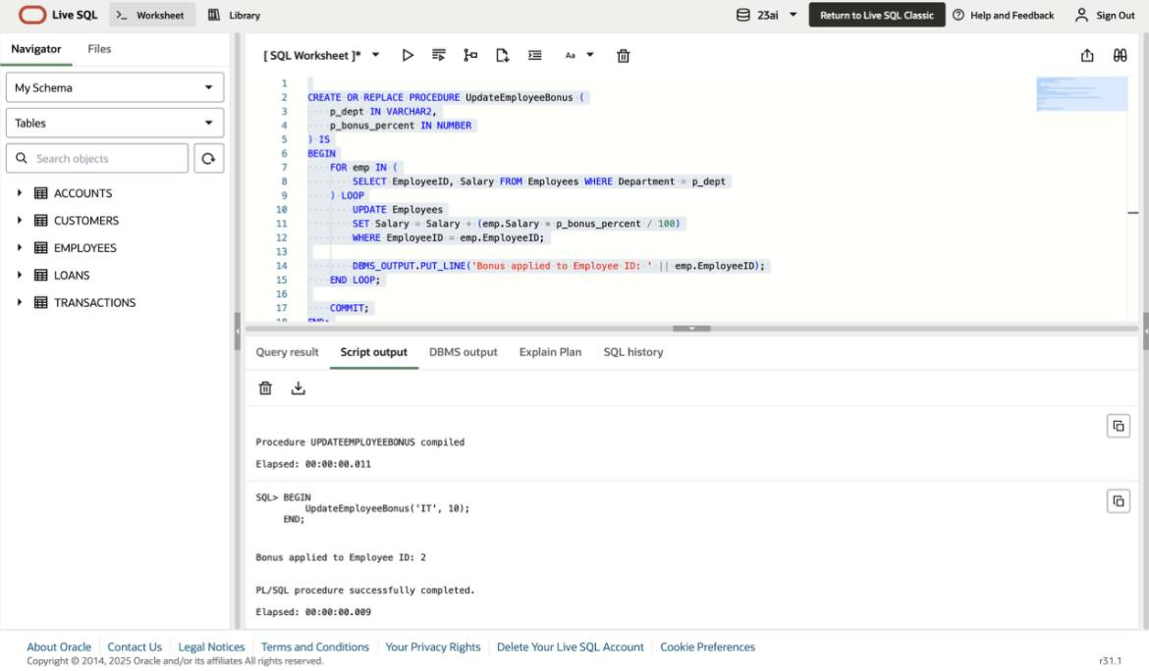

--Scenario 2

CREATE OR REPLACE FUNCTION CalculateMonthlyInstallment (

p_loan_amount IN NUMBER,

p_interest_rate IN NUMBER,

p_years IN NUMBER

) RETURN NUMBER

IS

v_emi NUMBER;

r NUMBER := p_interest_rate / 12 / 100;

n NUMBER := p_years * 12;

BEGIN

IF r = 0 THEN

v_emi := p_loan_amount / n;

ELSE

v_emi := p_loan_amount * r * POWER(1 + r, n) / (POWER(1 + r, n) - 1);

END IF;

RETURN ROUND(v_emi, 2);

END;

/

SELECT LoanID, CustomerID,

LoanAmount,

InterestRate,

ROUND(MONTHS_BETWEEN(EndDate, StartDate)/12) AS Years,

CalculateMonthlyInstallment(LoanAmount, InterestRate, ROUND(MONTHS_BETWEEN(EndDate, StartDate)/12)) AS EMI

FROM Loans;



--scenario 3

CREATE OR REPLACE FUNCTION HasSufficientBalance (

p_account_id IN NUMBER,

p_amount IN NUMBER

) RETURN BOOLEAN

IS

v_balance NUMBER;

BEGIN

SELECT Balance INTO v_balance

FROM Accounts

WHERE AccountID = p_account_id;

RETURN v_balance >= p_amount;

EXCEPTION

WHEN NO_DATA_FOUND THEN

RETURN FALSE;

END;

/

DECLARE

v_result BOOLEAN;

BEGIN

v_result := HasSufficientBalance(1, 500);

IF v_result THEN

DBMS_OUTPUT.PUT_LINE('Sufficient balance.');

ELSE

DBMS_OUTPUT.PUT_LINE('Insufficient balance.');

END IF;

END;

/

SELECT * FRom ACCOUNTS;

